LAB ASSIGNMENT: 4.2
  - Task Description#1
- Zero-shot: Prompt AI with only the instruction — Write a Python function to generate the Fibonacci sequence up to n terms
  - Expected Output#1
- A working function without using any sample inputs/outputs.
PROMPT

SNIPPET
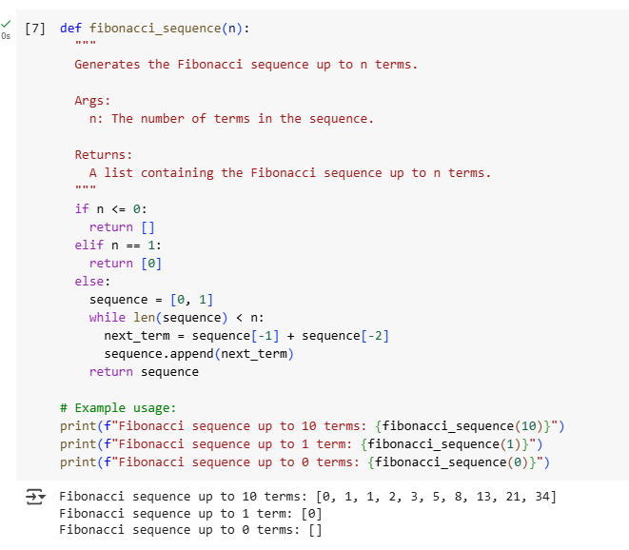

OBSERVATION
As I have given zeroshot prompt AI given output with example input also

  - Task Description#2
  - One-shot: Provide one example: Input: 100, Output: 37.78 to help AI generate a function that converts Fahrenheit to Celsius.
  - Expected Output#2
  - A correct conversion function guided by the single example.

PROMPT
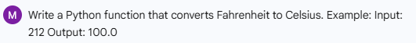

SNIPPET
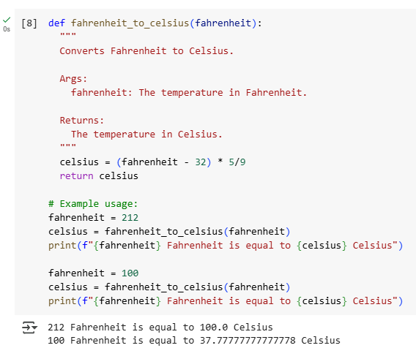

  - Task Description#4
  - Compare zero-shot vs few-shot prompting for generating a function that checks whether a word is a palindrome, ignoring punctuation and case.
  - Expected Output#4
  - Output comparison + student explanation on how examples helped the model

PROMPT
Zero shot
few shot
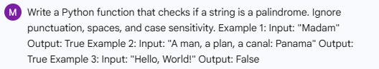

SNIPPET
zero shot
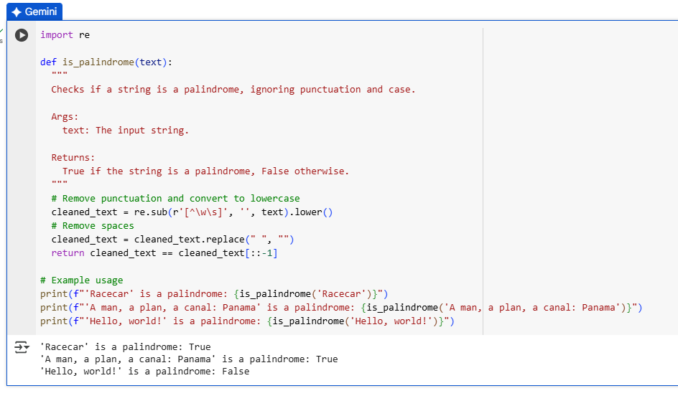
few shot
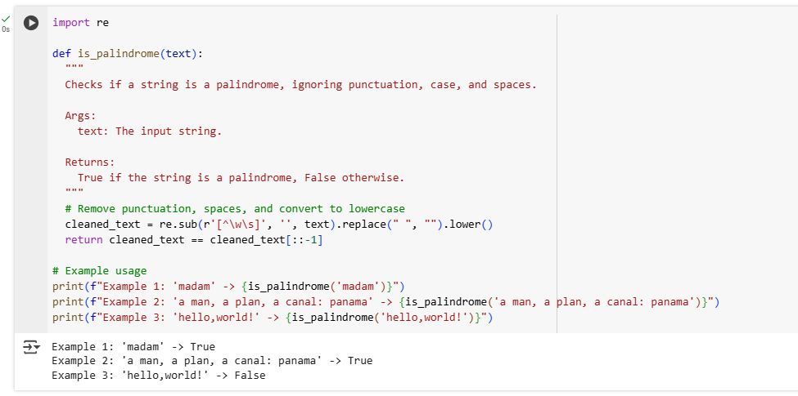

Output comparison
Example Input | Output in few shot | Output in zero shot | Verdict
"madam" | True | Not included | ✅ Palindrome
"a man, a plan, a canal: panama" | True | True | ✅ Palindrome
"hello,world!" | False | False | ❌ Not a Palindrome
"Racecar" | Not included | True | ✅ Palindrome
Explanation
The examples in both code snippets played a key role in guiding the model to generate a correct and generalizable palindrome-checking function:
- Example diversity: By including simple words like "madam" and complex phrases like "a man, a plan, a canal: Panama", the model learned to handle both basic and punctuation-heavy inputs.
- Edge case handling: "Hello, world!" helped the model understand that not all strings with punctuation are palindromes, reinforcing the need for accurate cleaning.
- Case sensitivity: "Racecar" demonstrated that the function must normalize case before comparison.
- Cleaning logic: The examples implicitly taught the model to remove punctuation and spaces, even though that wasn’t explicitly stated in the prompt.
Together, these examples formed a few-shot prompt that shaped the model’s understanding of what a robust palindrome function should do—without needing a long explanation.

Task Description#5
Use few-shot prompting with 3 sample inputs to generate a function that determines the maximum of three numbers without using the built-in max() function.
Expected Output#5
A function that handles all cases with correct logic based on example patterns.

Prompt
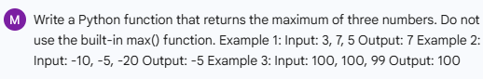

Snippet
